Week of: January 18-22, 2021 | Grade Level: 3rd
IB PYP Unit 4: How the World Works Central Idea: Energy can transform the world around us.
Prioritized Standards Addressed This Week:
Math
ON:
MGSE3.MD.7 Relate area to the operations of multiplication and addition.
a. Find the area of a rectangle with whole-number side lengths by tiling it and show that the area is the same as would be found by multiplying the side lengths.
b. Multiply side lengths to find areas of rectangles with whole number side lengths in the context of solving real world and mathematical problems and represent whole-number products as rectangular areas in mathematical reasoning.
c. Use tiling to show in a concrete case that the area of a rectangle with whole-number side lengths a and b + c is the sum of a × b and a × c. Use area models to represent the distributive property in mathematical reasoning.

ADV:
MGSE4.NBT.1 Recognize that in a multi-digit whole number, a digit in any one place represents ten times what it represents in the place to its right. For example, recognize that 700 ÷ 70 = 10 by applying concepts of place value and division.
MGSE4.NBT.2 Read and write multi-digit whole numbers using base-ten numerals, number names, and expanded form. Compare two multi-digit numbers based on meanings of the digits in each place, using >, =, and < symbols to record the results of comparisons.
MGSE4.NBT.3 Use place value understanding to round multi-digit whole numbers to any place. Use place value understanding and properties of operations to perform multi-digit arithmetic.
MGSE4.NBT.4 Fluently add and subtract multi-digit whole numbers using the standard algorithm

ACC:
MGSE4.NF.3 Understand a fraction 𝑎/𝑏 with a numerator >1 as a sum of unit fractions 1/b. a. Understand addition and subtraction of fractions as joining and separating parts referring to the same whole. b. Decompose a fraction into a sum of fractions with the same denominator in more than one way, recording each decomposition by an equation. Justify decompositions, e.g., by using a visual fraction model. Examples: 3/8 = 1/8 + 1/8 + 1/8 ; 3/8 = 1/8 + 2/8 ; 2 1/8 = 1 + 1 + 1/8 = 8/8 + 8/8 + 1/8. c. Add and subtract mixed numbers with like denominators, e.g., by replacing each mixed number with an equivalent fraction, and/or by using properties of operations and the relationship between addition and subtraction. d. Solve word problems involving addition and subtraction of fractions referring to the same whole and having like denominators, e.g., by using visual fraction models and equations to represent the problem.
MGSE4.NF.4 Apply and extend previous understandings of multiplication to multiply a fraction by a whole number e.g., by using a visual such as a number line or area model. a. Understand a fraction a/b as a multiple of 1/b. For example, use a visual fraction model to represent 5/4 as the product 5 × (1/4), recording the conclusion by the equation 5/4 = 5 × (1/4). b. Understand a multiple of a/b as a multiple of 1/b, and use this understanding to multiply a fraction by a whole number. For example, use a visual fraction model to express 3 × (2/5) as 6 × (1/5), recognizing this product as 6/5. (In general, n × (a/b) = (n × a)/b.) c. Solve word problems involving multiplication of a fraction by a whole number, e.g., by using visual fraction models and equations to represent the problem. For example, if each person at a party will eat 3/8 of a pound of roast beef, and there will be 5 people at the party, how many pounds of roast beef will be needed? Between what two whole numbers does your answer lie?

Reading/ ELA:
ELAGSE3RL2: Recount stories, including fables, folktales, and myths from diverse cultures; determine the central message, lesson, or moral and explain how it is conveyed through key details.
ELAGSE3RL3: Describe characters in a story.
ELAGSE3SL4: Report on a topic or text, tell a story, or recount an experience with appropriate facts and relevant, descriptive details, speaking clearly at an understandable pace.
ELAGSE3RL5: Refer to parts of stories, dramas, and poems when writing or speaking about a text, using terms such as chapter, scene, and stanza; describe how each successive part builds on earlier sections.
ELAGSE3RL9: Compare and contrast the themes, settings, and plots of stories written by the same author about the same or similar characters (e.g., in books from a series).
ELAGSE3SL4: Report on a topic or text, tell a story, or recount an experience with appropriate facts and relevant, descriptive details, speaking clearly at an understandable pace

ELAGSE3L1. Demonstrate command of the conventions of standard English grammar and usage when writing or speaking.
f. Use spelling patterns and generalizations (e.g., word families, position-based spellings, syllable patterns, ending rules, meaningful word parts) in writing words.
ELAGSE3W2: Write informative/explanatory texts to examine a topic and convey ideas and information clearly. a. Introduce a topic and group related information together; include illustrations when useful to aiding comprehension. b. Develop the topic with facts, definitions, and details. c. Use linking words and phrases (e.g., also, another, and, more, but) to connect ideas within categories of information. d. Provide a concluding statement or section.
ELAGSE3W5: With guidance and support from peers and adults, develop and strengthen writing as needed by planning, revising, and editing. (Editing for conventions should demonstrate command of Language standards 1–3 up to and including grade 3.)

Science
S3P1: Obtain, evaluate, and communicate information about the ways heat energy is transferred and measured.
a. Ask questions to identify sources of heat energy. (Clarification statement: Examples could include sunlight, friction, and burning.)
c. Use tools and everyday materials to design and construct a device/structure that will increase/decrease the warming effects of sunlight on various materials.
(Clarification statement: Conduction, convection, and radiation are taught in upper grades.)
Asterisk & Highlighted items will be graded

 | MONDAY | TUESDAY | WEDNESDAY | THURSDAY | FRIDAY
Morning Meeting  15 mins. | No School! 😊 | -Heards Ferry Live  -Overview of the week  -Social Emotional Lesson: Empathy Video | -Heards Ferry Live  -Social Emotional Lesson: Empathy Discussion | -Heards Ferry Live  -Social Emotional Lesson: Empathy Activity | -Heards Ferry Live  -Social Emotional Lesson: Empathy Activity (if needed)  -Announce SOTW
ON Math | NO SCHOOL 😊! | Mini Lesson:  Teacher will review the distributive property to find area with a video.  https://youtu.be/Q3wfb0CPhIY  POTD (files)  Guided Practice:  Area with Distributive Property Task Cards  (files)  Independent:  iReady Math | Mini Lesson:  Finding Area-Distributive Property WS (files)  Review as a class  Guided Practice:  Area Distributive Property Task Cards & Worksheet (files)  Independent:  Area with Distributive Property WS (due Friday-GRADED) | Mini Lesson:  Area Review Game  https://jeopardylabs.com/play/3rd-grade-area-review-game  Guided Practice:  Area Distributive Property Worksheet (files)  Independent:  iReady Math | Area Quiz!
ADV Math | NO SCHOOL 😊! | Mini Lesson:  Review how to round numbers to the nearest ten and hundred. Show that you can use the same strategy with larger numbers.  Guided Practice:  Practice adding 5-7 digit numbers with regrouping. The teacher will write a few problems on the white board for students to solve.  Independent:  Place Value Puzzler (Grade) | Mini Lesson:  Review subtraction with regrouping  https://youtu.be/Y6M89-6106I  Guided Practice: TAG DAY  Make 2 small groups and work with one today and one tomorrow.  Review subtraction with regrouping. Use examples on workbook pages 93-94.  Independent:  Workbook page 95 evens only  Due Friday  Iready math | Mini Lesson:  Practice subtraction across zeros. 9,000 – 5,637  20,000 – 3,648  30,090-22,977  Guided Practice:  Continue from yesterday...  Make 2 small groups and work with one today and one tomorrow.  Review subtraction with regrouping. Use examples on workbook pages 93-94.  Independent:  Workbook page 95 evens only  Due Friday  Iready math | Mini Lesson:  Review comparing numbers and place value. Write numbers on the board to use as examples.  Independent:  Place Value QUIZ (Grade)
ACC Math | No School! 😊 | Unit 4 Review  Mini Lesson:  Adding and Subtracting Fractions-  https://create.kahoot.it/share/adding-and-subtracting-fractions/33f5ffb1-1e7f-4002-be7f-44d7bb35ffdd  Improper Fractions and Mixed Numbers-  https://create.kahoot.it/share/mixed-numbers-and-improper-fractions/9b8a4459-0a83-4d8f-b090-5e0d614e730a  Independent:  IReady Math Lessons | Unit 4 Review  Mini Lesson:  Multiplying Fractions-  https://create.kahoot.it/share/multiplying-fractions-with-a-whole-number/b5cfc84d-32cd-4400-b13b-c3fbefc8a795  Word Problems-  Finish completed the word problems from the Flocabulary worksheet from last week (One Drive). Complete numbers 13-15 as a class.  **Use page 1 of the document if students need more multiplying practice.  Independent:  IReady Math Lessons  (Students will be pulled at 8:50am for TAG). | Unit 4 Test  (Unit 4 Post-Illuminate)  When finished, iReady Math Lessons | Unit 4 Test  (Unit 4 Post-Illuminate)  When finished, iReady Math Lessons

Reading | MLK HOLIDAY | Read Aloud  - Winn-Dixie: Ch.13-15  Focused Lesson  Bend II, Session 7: Stories are Shaped Like a Mountain, Readers Watch Characters Go Up and Down (Pg.59) | Focused Lesson  Review previous unit sessions.  -Have students share their theories about their individual characters  - Review Character Traits  https://www.youtube.com/watch?v=Bp01Egn90C8&t=20s | Read Aloud  - Winn-Dixie: Ch. 16-17  Focused Lesson  Bend II, Session 8: Readers Expect Characters to Face-and React to- Trouble (Pg. 69) | Read Aloud  - Winn-Dixie: Ch. 18-19  Focused Lesson  Bend II, Session 9: Readers Notice the Roles Secondary Characters Play in the Main Character’s Journey (pg. 79)
 |  | Student Independent Practice  SW read independently | Student Independent Practice  SW read independently | Student Independent Practice  SW read independently | Student Independent Practice  SW read independently
Phonics | No school | Prefix: micro-  - extremely small  - Size  Introduce Prefix and word list:  - Microscope  - Microphone  - Microwave  - Microbe  Highlight the prefix and underline the base word.  Discuss definitions. | Prefix: micro-  - extremely small  - size  Prefix Unscramble Activity  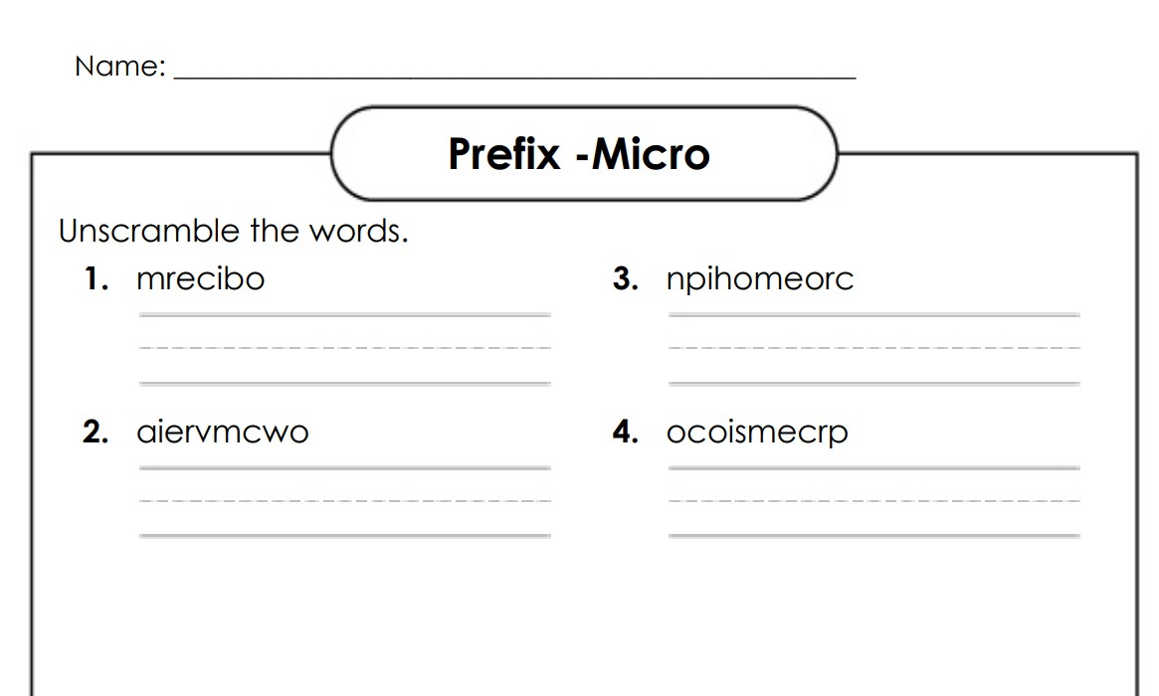 | Prefix: micro-  - extremely small  - Size  Prefix Missing Letters Activity  Graded  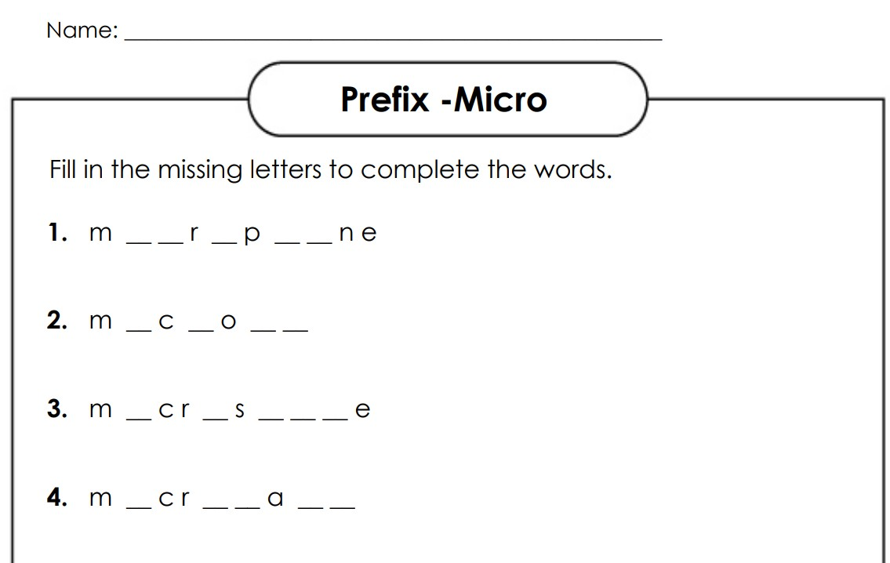 | Prefix: micro-  - extremely small  - size  Prefix Word Search 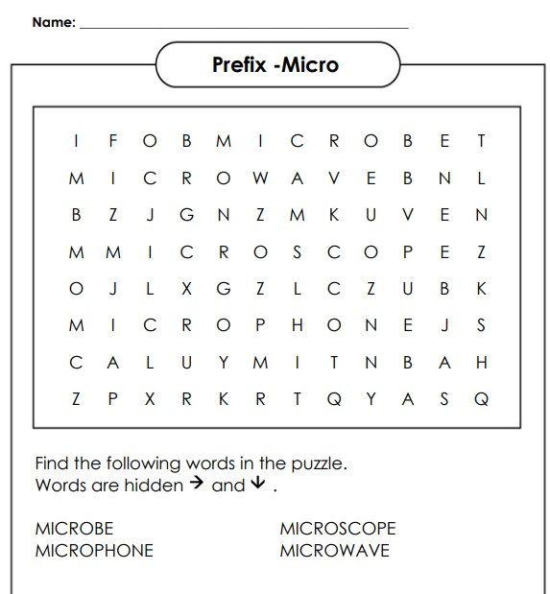
Writing | No School | Unit 4 (Baby Literacy) Session 1: A Guide to Boot Camp  “Writers, readers often share ideas about stories they have read together. Then they work together to gather evidence for an idea.”  Read aloud a short text (we suggest you use Each Kindness), with the lens of coming up with opinions about the characters. You might suggest that your students notice important character traits  Each Kindness Read Aloud  After reading the text, prompt students to share some possible opinions about the characters. Give them a minute to turn and talk with their partners about the story, listen in, and co-author with them as needed, and then jot these ideas on some large Post-it notes.  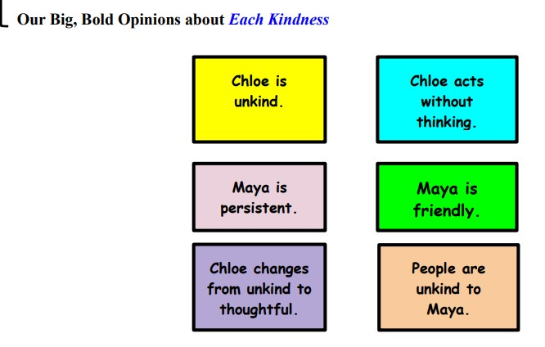  Work together to pick one idea to write about for today and let students know that you will work with the others on future days. Whatever you choose to do, keep the selection process quick as the bulk of the work will be to write the essay. | Review Session 1: A Guide to Boot Camp  Continue working together to pick one idea to write about for today and let students know that you will work with the others on future days. Whatever you choose to do, keep the selection process quick as the bulk of the work will be to write the essay. | Unit 4 (Baby Literacy) Session 2:  Repeating the Boot Camp with a New Claim  Post the chart of big, bold opinions students generated on Day 1. Invite the class to choose a new big, bold opinion to all write about today.  “Ready to try another boot camp today? This one is going to make your essay writing muscles extra strong. Now that we know the big, bold opinion we’ll write about today, we’ve got to find evidence to support that idea. Here’s my tip. As you look for evidence, try to look for a few different parts in the story that support that idea. Maybe there will be a part in the beginning and another part in the middle and even a part at the end. When you find a part that supports our claim, underline it so you can include the exact words in your essay.”  When Writing a Literary Essay, Writers...  - Name the story they are writing about  - State a big, bold opinion, or thesis  - Give evidence from the story  - Restate your thesis, tell what happens at the end, or give a lesson the character learns | Unit 4 (Baby Literacy) Session 3: Writers Draft More Than One Idea, Raising the Level of Their Work with Specific Text Evidence.  “Writers, today I want to teach you that one way that essayists raise the level of their essays is by including summaries or exact lines from the story as evidence.”  When Writing a Literary Essay, Writers...  - Name the story they are writing about  - State a big, bold opinion, or thesis  - Give evidence from the story  - summarize parts of the story  - quote exact lines  - Restate your thesis, tell what happens at the end, or give a lesson the character learns
Science | MLK Holiday!  No school. 😊 | Focused Lesson  Explain to the students that they will now be learning about heat energy and how it is transferred and measured. Before giving the definition of heat energy, ask students if they know anything about heat energy and how it is transferred and measured.  Heat energy: is the transfer of energy from one object to another due to temperature.  We will then begin reading and discussing pgs. 60-63 in the science textbook. | Focused Lesson  The teacher will review the definition of heat energy. The class will then watch the Brainpopjr video on Heat: https://jr.brainpop.com/science/energy/heat/ | Focused Lesson  The class will continue reading the Heat Energy chapter. We will read and discuss pgs. 64-67. | Focused Lesson  The teacher will show the Heat Transfer anchor chart to review with the class.  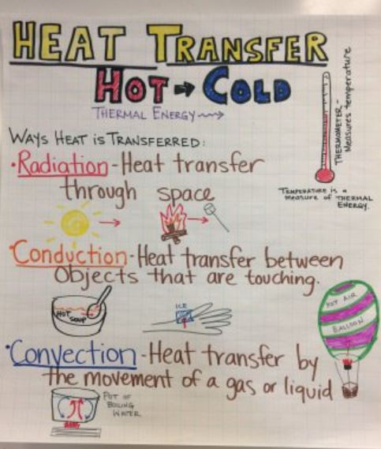
 |  | Student Independent Practice  The students will answer questions #’s 1-3 form pg. 103 in their science workbook. | Student Independent Practice  The students will independently complete the Heat easy and hard quizzes.  *assign to students in the BrainPop Jr app.* | Student Independent Practice  The students will complete questions 8-10 from pg.105 in their workbook. They will then complete #’s 11-12 on pg.107. | Student Independent Practice  The students will complete the conduction, convection, and radiation assignment.  *graded 12 points.
Due Dates |  |  |  | Prefix Missing Letters Activity  Graded | ACC Unit 4 Test  Conduction, Convection, and Radiation assignment  Area with Distributive Property WS  ON- Area Quiz
